Compiler Design
Lab Assessment 2

Student Name: Avyakth Shriram
Register Number: 24BCE5461

PROGRAM 1
first_and_follow.c

Aim:
To write a C program that parses Context-Free Grammar (CFG) productions and dynamically computes the FIRST and FOLLOW sets for all non-terminals, aiding top-down parser implementation.

Objective:
- To parse, tokenize, and store grammar production rules, non-terminals, and terminals.
- To recursively/iteratively evaluate FIRST() sets by processing terminal prefixes and handling nullability (epsilon e).
- To evaluate FOLLOW() sets by scanning production right-hand sides, accounting for adjacent grammar symbols and end-of-input markers ($).

C Program Code:

#include <stdio.h>
#include <stdlib.h>
#include <string.h>
#include <ctype.h>

#define MAX_PROD 20
#define MAX_SYMBOLS 50
#define MAX_LEN 20

typedef struct {
char lhs[MAX_LEN];
char rhs[MAX_PROD][MAX_LEN];
int rhs_count;
} Production;

Production prods[MAX_PROD];
int prod_count = 0;

char non_terminals[MAX_SYMBOLS][MAX_LEN];
int nt_count = 0;

char terminals[MAX_SYMBOLS][MAX_LEN];
int t_count = 0;

int first_set[MAX_SYMBOLS][MAX_SYMBOLS];
int follow_set[MAX_SYMBOLS][MAX_SYMBOLS];

int get_nt_index(char *str) {
for (int i = 0; i < nt_count; i++) {
if (strcmp(non_terminals[i], str) == 0) return i;
}
return -1;
}

int get_t_index(char *str) {
for (int i = 0; i < t_count; i++) {
if (strcmp(terminals[i], str) == 0) return i;
}
return -1;
}

void add_nt(char *str) {
if (get_nt_index(str) == -1 && strlen(str) > 0) {
strcpy(non_terminals[nt_count++], str);
}
}

void add_t(char *str) {
if (get_nt_index(str) == -1 && get_t_index(str) == -1 && strlen(str) > 0) {
strcpy(terminals[t_count++], str);
}
}

int is_nt(char *str) {
return get_nt_index(str) != -1;
}

int tokenize_rhs(char *rhs_raw, char tokens[MAX_PROD][MAX_LEN]) {
int t_idx = 0;
int i = 0;
int len = strlen(rhs_raw);

while (i < len) {
if (rhs_raw[i] == 'i' && i + 1 < len && rhs_raw[i+1] == 'd') {
strcpy(tokens[t_idx++], "id");
i += 2;
} else if (i + 1 < len && rhs_raw[i+1] == '\'') {
tokens[t_idx][0] = rhs_raw[i];
tokens[t_idx][1] = '\'';
tokens[t_idx][2] = '\0';
t_idx++;
i += 2;
} else {
tokens[t_idx][0] = rhs_raw[i];
tokens[t_idx][1] = '\0';
t_idx++;
i++;
}
}
return t_idx;
}

void compute_first() {
int change = 1;
while (change) {
change = 0;
for (int i = 0; i < prod_count; i++) {
int lhs_idx = get_nt_index(prods[i].lhs);

for (int j = 0; j < prods[i].rhs_count; j++) {
char tokens[MAX_PROD][MAX_LEN];
int token_count = tokenize_rhs(prods[i].rhs[j], tokens);

if (token_count == 1 && strcmp(tokens[0], "e") == 0) {
int eps_idx = get_t_index("e");
if (!first_set[lhs_idx][eps_idx]) {
first_set[lhs_idx][eps_idx] = 1;
change = 1;
}
continue;
}

int k = 0;
int continue_loop = 1;
while (k < token_count && continue_loop) {
continue_loop = 0;
char *sym = tokens[k];

if (!is_nt(sym)) {
int t_idx = get_t_index(sym);
if (!first_set[lhs_idx][t_idx]) {
first_set[lhs_idx][t_idx] = 1;
change = 1;
}
} else {
int sym_nt_idx = get_nt_index(sym);
for (int t = 0; t < t_count; t++) {
if (strcmp(terminals[t], "e") != 0 && first_set[sym_nt_idx][t]) {
if (!first_set[lhs_idx][t]) {
first_set[lhs_idx][t] = 1;
change = 1;
}
}
}
if (first_set[sym_nt_idx][get_t_index("e")]) {
continue_loop = 1;
}
}
k++;
}
if (k == token_count && continue_loop) {
int eps_idx = get_t_index("e");
if (!first_set[lhs_idx][eps_idx]) {
first_set[lhs_idx][eps_idx] = 1;
change = 1;
}
}
}
}
}
}

void compute_follow() {
follow_set[get_nt_index(prods[0].lhs)][get_t_index("$")] = 1;

int change = 1;
while (change) {
change = 0;
for (int i = 0; i < prod_count; i++) {
int lhs_idx = get_nt_index(prods[i].lhs);

for (int j = 0; j < prods[i].rhs_count; j++) {
char tokens[MAX_PROD][MAX_LEN];
int token_count = tokenize_rhs(prods[i].rhs[j], tokens);

for (int k = 0; k < token_count; k++) {
char *sym = tokens[k];
if (!is_nt(sym)) continue;
int sym_nt_idx = get_nt_index(sym);

int next_pos = k + 1;
int continue_loop = 1;

while (next_pos < token_count && continue_loop) {
continue_loop = 0;
char *next_sym = tokens[next_pos];

if (!is_nt(next_sym)) {
int t_idx = get_t_index(next_sym);
if (!follow_set[sym_nt_idx][t_idx]) {
follow_set[sym_nt_idx][t_idx] = 1;
change = 1;
}
} else {
int next_nt_idx = get_nt_index(next_sym);
for (int t = 0; t < t_count; t++) {
if (strcmp(terminals[t], "e") != 0 && first_set[next_nt_idx][t]) {
if (!follow_set[sym_nt_idx][t]) {
follow_set[sym_nt_idx][t] = 1;
change = 1;
}
}
}
if (first_set[next_nt_idx][get_t_index("e")]) {
continue_loop = 1;
}
}
next_pos++;
}

if (next_pos == token_count && continue_loop) {
for (int t = 0; t < t_count; t++) {
if (follow_set[lhs_idx][t]) {
if (!follow_set[sym_nt_idx][t]) {
follow_set[sym_nt_idx][t] = 1;
change = 1;
}
}
}
}
}
}
}
}
}

// Custom sort function that handles special terminal priorities perfectly
int compare_terminals(const void *a, const void *b) {
char *strA = (char *)a;
char *strB = (char *)b;

// Always force epsilon 'e' to the end of FIRST sets
if (strcmp(strA, "e") == 0) return 1;
if (strcmp(strB, "e") == 0) return -1;

// Always force end-marker '$' to the end of FOLLOW sets
if (strcmp(strA, "$") == 0) return 1;
if (strcmp(strB, "$") == 0) return -1;

return strcmp(strA, strB);
}

void print_set(int set_matrix[MAX_SYMBOLS][MAX_SYMBOLS], int nt_idx) {
printf("{");

// Create a temporary sorted array of matching items for the current row
char matches[MAX_SYMBOLS][MAX_LEN];
int m_count = 0;

for (int t = 0; t < t_count; t++) {
if (set_matrix[nt_idx][t]) {
strcpy(matches[m_count++], terminals[t]);
}
}

// Apply order sort
qsort(matches, m_count, MAX_LEN, compare_terminals);

for (int i = 0; i < m_count; i++) {
printf("%s", matches[i]);
if (i < m_count - 1) printf(",");
}
printf("}");
}

int main() {
int n;
printf("Enter the no. of production:");
if (scanf("%d", &n) != 1) return 1;
prod_count = n;

char raw_line[MAX_LEN * 3];
for (int i = 0; i < n; i++) {
scanf("%s", raw_line);

char *arrow = strstr(raw_line, "->");
*arrow = '\0';
strcpy(prods[i].lhs, raw_line);
add_nt(prods[i].lhs);

char *rhs_part = arrow + 2;
char *token = strtok(rhs_part, "/");
prods[i].rhs_count = 0;
while (token != NULL) {
strcpy(prods[i].rhs[prods[i].rhs_count++], token);
token = strtok(NULL, "/");
}
}

// Dynamic extraction phase for terminal matching sets
for (int i = 0; i < prod_count; i++) {
for (int j = 0; j < prods[i].rhs_count; j++) {
char tokens[MAX_PROD][MAX_LEN];
int token_count = tokenize_rhs(prods[i].rhs[j], tokens);
for (int k = 0; k < token_count; k++) {
if (strcmp(tokens[k], "e") != 0) {
add_t(tokens[k]);
}
}
}
}
add_t("e");
add_t("$");

compute_first();
compute_follow();

printf("\nFirst\n");
for (int i = 0; i < nt_count; i++) {
printf("First(%s)=", non_terminals[i]);
print_set(first_set, i);
printf("\n");
}

printf("\nFollow\n");
for (int i = 0; i < nt_count; i++) {
printf("Follow(%s)=", non_terminals[i]);
print_set(follow_set, i);
printf("\n");
}

return 0;
}

Output/Screenshots:

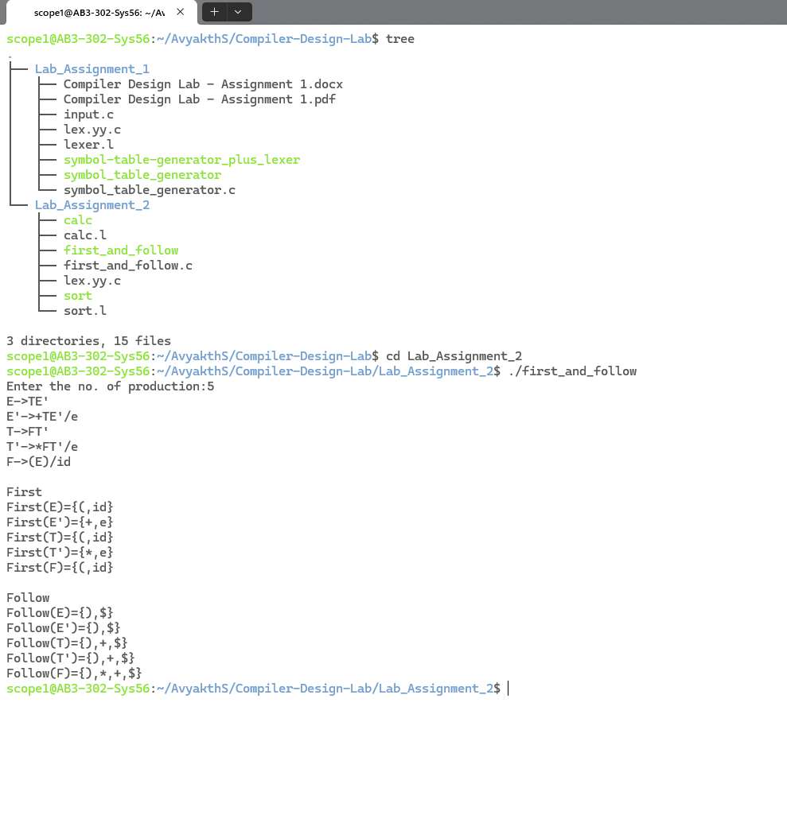

PROGRAM 2
calc.l

Aim:
To design and implement a simple interactive arithmetic calculator using Lex (Flex) to perform token recognition and state-driven calculation for two-number arithmetic operations.

Objective:
- To construct regular expressions in Lex that identify numbers (integers and floats) and basic arithmetic operators (+, -, *, /, %).
- To implement a finite state tracker that validates the input sequence format ([Number] [Operator] [Number]).
- To execute calculations and gracefully handle invalid syntax or division-by-zero errors.

C Program Code:

%{
#include <stdio.h>
#include <stdlib.h>

double num1 = 0, num2 = 0;
char op = 0;

/* State tracker:
0 = expect first number
1 = expect operator
2 = expect second number
3 = calculation ready
*/
int state = 0;

/* Helper function to perform the math */
void calculate() {
if (state != 3) {
printf("Error: Incomplete expression. Please enter format: [Number] [Operator] [Number]\n");
return;
}

switch(op) {
case '+': printf("Result: %g\n", num1 + num2); break;
case '-': printf("Result: %g\n", num1 - num2); break;
case '*': printf("Result: %g\n", num1 * num2); break;
case '/':
if (num2 != 0.0) {
printf("Result: %g\n", num1 / num2);
} else {
printf("Error: Division by zero\n");
}
break;
case '%':
printf("Result: %d\n", (int)num1 % (int)num2);
break;
}
}

/* Helper function to reset for the next calculation */
void reset() {
num1 = 0;
num2 = 0;
op = 0;
state = 0;
printf("Enter calculation (e.g., 5 + 3): ");
}
%}

%%

[0-9]+(\.[0-9]+)? {
if (state == 0) {
num1 = atof(yytext);
state = 1; /* Now look for an operator */
}
else if (state == 2) {
num2 = atof(yytext);
state = 3; /* Now ready to calculate */
}
else if (state == 3) {
printf("Error: Only two numbers are allowed per calculation.\n");
}
else {
printf("Error: Expected an operator, but got a number.\n");
}
}

[+\-*/%] {
if (state == 1) {
op = yytext[0];
state = 2; /* Now look for the second number */
}
else {
printf("Error: Operator '%s' is out of place.\n", yytext);
}
}

\n {
/* When the user hits Enter, calculate and reset */
if (state > 0) {
calculate();
}
reset();
}

[ \t] { /* Ignore spaces and tabs */ }

. { printf("Invalid character: %s\n", yytext); }

%%

int yywrap() {
return 1;
}

int main() {
printf("--- Two-Number Lex Calculator ---\n");
printf("Format: [Number] [Operator] [Number]\n");
reset();
yylex();
return 0;
}

Output/Screenshots:

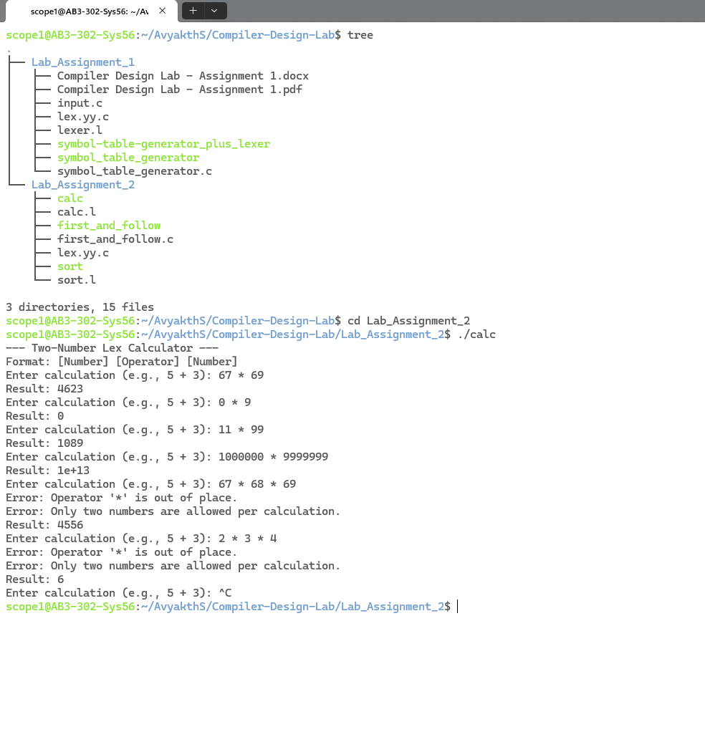

PROGRAM 3
sort.l

Aim:
To develop a Lex specification file that extracts numerical sequences from standard input and sorts them in ascending order using a embedded sorting algorithm.

Objective:
- To write Lex regular expressions that capture positive/negative integers and floating-point numbers while filtering out whitespace and invalid characters.
- To store tokenized numbers into an internal dynamic/static array buffer.
- To apply an inline sorting routine (Bubble Sort) when a newline delimiter (\n) is encountered and print the sorted output.

C Program Code:

%{
#include <stdio.h>
#include <stdlib.h>

#define MAX_SIZE 100

double arr[MAX_SIZE];
int count = 0;

/* Standard Bubble Sort implementation in C */
void bubble_sort() {
if (count == 0) {
return; /* Nothing to sort */
}

for (int i = 0; i < count - 1; i++) {
for (int j = 0; j < count - i - 1; j++) {
if (arr[j] > arr[j+1]) {
/* Swap the elements */
double temp = arr[j];
arr[j] = arr[j+1];
arr[j+1] = temp;
}
}
}

/* Print the sorted array */
printf("Sorted result: ");
for (int i = 0; i < count; i++) {
printf("%g ", arr[i]);
}
printf("\n");
}

/* Reset the array counter for the next input */
void reset() {
count = 0;
printf("Enter numbers separated by spaces: ");
}
%}

%%

-?[0-9]+(\.[0-9]+)? {
/* When a number is found, add it to the array */
if (count < MAX_SIZE) {
arr[count] = atof(yytext);
count++;
} else {
printf("Warning: Array full (max %d). Ignoring %s\n", MAX_SIZE, yytext);
}
}

\n {
/* When Enter is pressed, sort the array and reset */
bubble_sort();
reset();
}

[ \t] { /* Ignore spaces and tabs */ }

. {
/* Catch letters or special characters */
printf("Invalid character ignored: %s\n", yytext);
}

%%

int yywrap() {
return 1;
}

int main() {
printf("--- Lex Bubble Sorter ---\n");
reset();
yylex();
return 0;
}

Output/Screenshots:

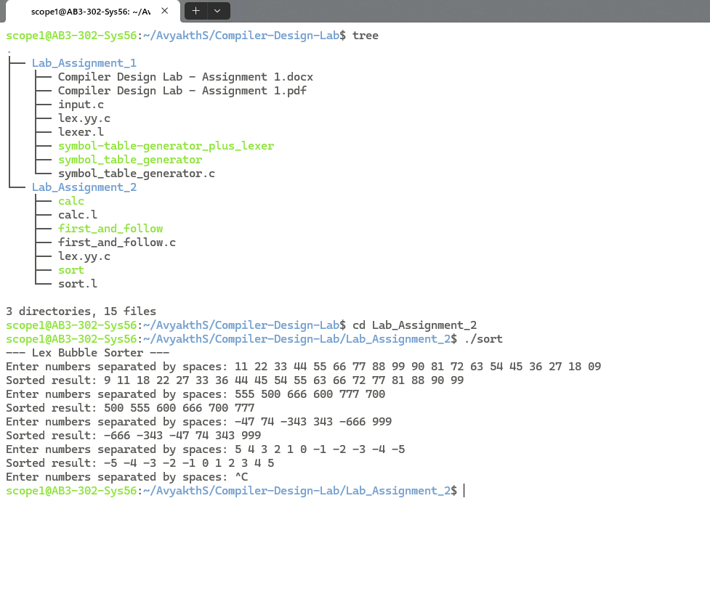

THANK YOU

